**REPORT**

**LAB 2**

**Student name: Hồ Nguyên Hà**

**Student ID: 20IT043**

**Student email: hnha.20it2@vku.udn.vn**

# **Introduction**

* This report briefly describes the purpose of the laboratory experiment on the development of the mobile application **micard**.
* The **micard** mobile application allows users to create a card with their personal information, including phone number and email address.

# **Objectives**

* The objective of the laboratory is to create a mobile application that allows users to create a card with their personal information.

# **Methodology**

* The laboratory uses a cross-platform mobile application development method to create the **micard** application.
* The application is developed using the latest technologies to ensure the best features and performance.

# **Results**

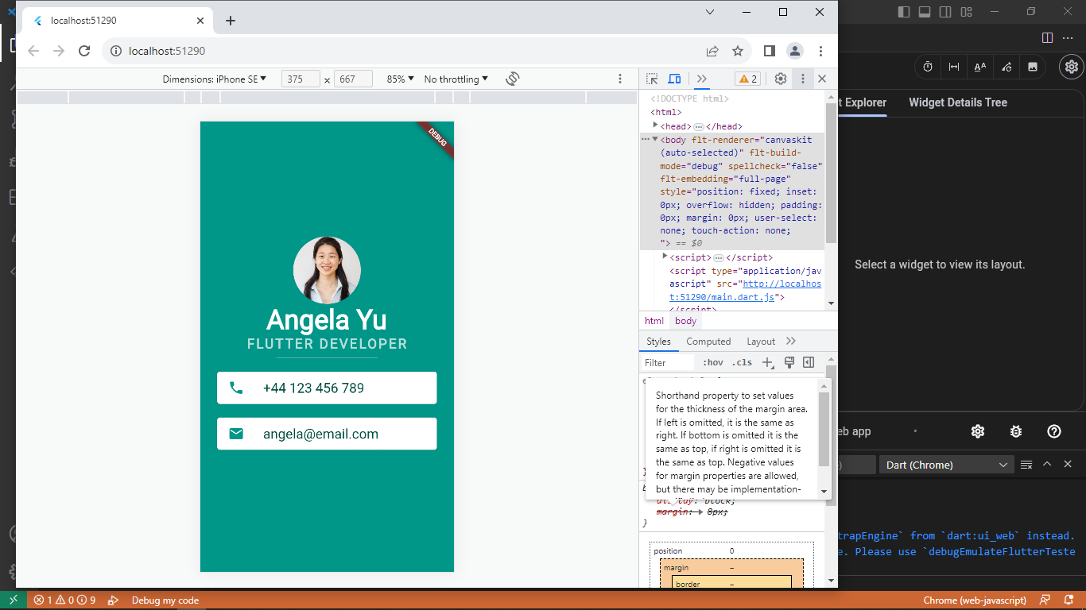

* The experimental results show that the **micard** application works well and allows users to easily create a card with their personal information.

# **Discussion**

* The experimental results show that the **micard** application has achieved the laboratory’s objective.
* The strength of cross-platform mobile application development is that it allows the application to run on multiple platforms, thereby attracting more users. However, the weakness is that development may take more time and effort than developing separately for each platform.

# **Conclusion**

* The laboratory has succeeded in creating a mobile application that allows users to create a card with their personal information.
* In the future, we can continue to improve and add new features to the **micard** application to attract more users.